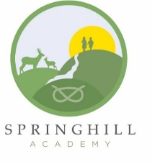



**Springhill Academy**

**Base Camp**

**Year 4 & 5**

Dear Parent/Carer

As we make our final preparations for Year 4 & 5 to take part in Base Camp next week I have attached essential paperwork to be completed prior to the adventure.

Please be reminded that your child must bring a packed lunch for day 1 and the school kitchen will provide grab bags for your child on Friday, paid for by the school. All other meals are provided for by the Base Camp organisers.

Please find enclosed the following items:

* A suggested kit list.
* A Medical Declaration to be completed and returned By Wednesday 2nd October.
* A copy of the Base Camp presentation.

Hopefully all your questions have been answered at the Base Camp meeting, if you were unable to attend this meeting and need further information please do not hesitate to call the school office.

Kind regards

Mrs N Silvester-Grant

Head of School